

**CAR RENTAL SYSTEM**

**DATA BASE MANAGEMENT SYSTEMS**



|  |  |  |  |
| --- | --- | --- | --- |
| S.No | ROLL_No | NAME | ROLE |
| 1 | CSE459 | SHANTHAN REDDY | LEADER |
| 2 | CSE453 | ABHINAV RAVELLA | DESIGNER |
| 3 | CSE449 | SAI KOUSHIK | DEVELOPER |
| 4 | CSE405 | SATYA HEMANTH | TESTING AND DOCUMENTING |

**INDEX :**

**ABSTRACT**

Car rental system is an online system where customers can rent different kinds of cars of their interest. The main aim of this project is to design and develop a database for the car rental company to maintain the records of different types of information such as customer details, different cars details and it would be easy to keep track of different cars. This system simplifies the assignment of different cars and also increases the efficiency as it attracts many new customers.

**PREVIEW OF THE PROJECT**

**INTRODUCTION:**

This system keeps track of information of different kinds of cars in different locations, the status of every car. A customer can check availability of cars in his location and can book the car. while booking a customer is asked to submit his/her license/Aadhaar card number for safety. A caution deposit is also need to be submitted before the pickup. The customer is asked about from and to date to rent a car. A customer can return the car after the to date as well but they will be charged with some late fee. If customer wants to cancel the booking, they can cancel the booking 5 days before the actual pickup. If the customer rents the car for the first time then they are granted with the discount coupon. Billing is done after they return the car.

**NEEDED FOR ?**

This system makes the customers work to search for cars easy as all the details about the availability of different cars are available. This system also helps the car rental company to find the customers easily.

TOOLS USED:

• For Database - SQL

• For User Interface - Java

**ENTITY-RELATIONSHIP MODEL**

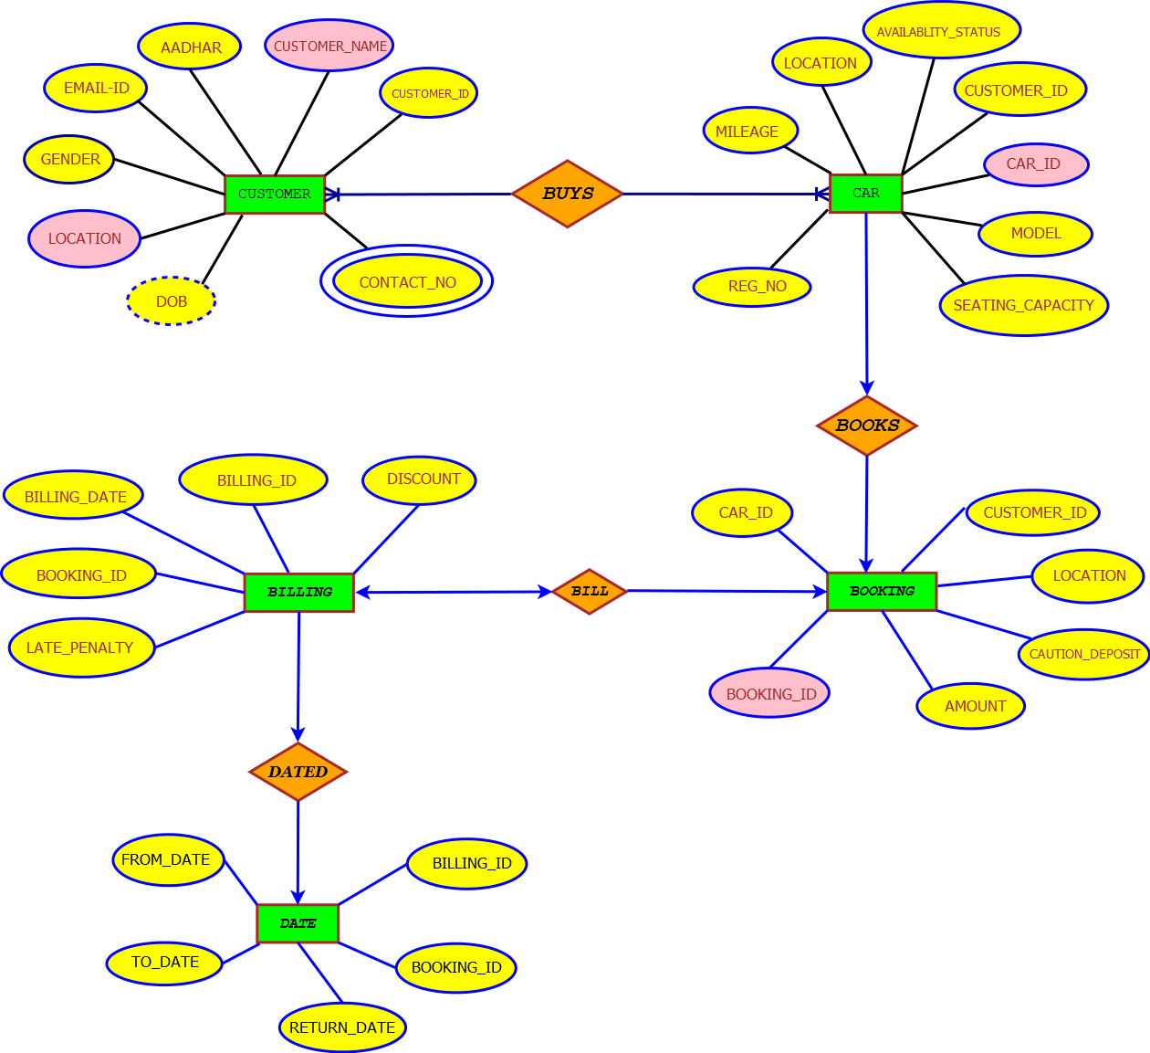

**EXTENDED ER**

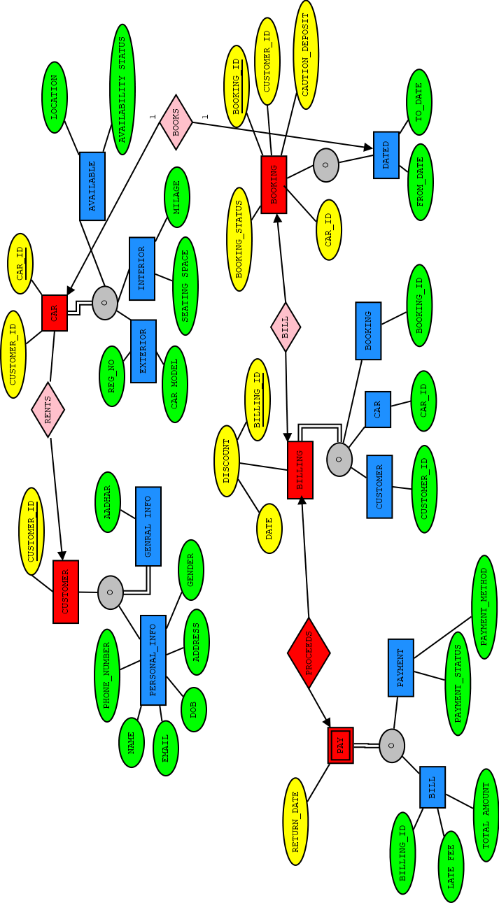

**NORMALISED SCHEMA**

